 | 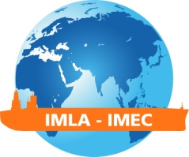 | IMLA – IMEC 27 CONFERENCE REGISTRATION FORM  Netherlands Maritime Institute of Technology  Johor Bahru, Malaysia  October 12 – 17 2015
 | Please complete and return this form to the conference organizer at 27imec@gmail.com.
 | Title: | Mr. | Ms. | Dr. | Prof |  | Others  (please specify)
 | Attending as: | Presenter |  | Participant
 | Gender: | Male |  |  | Female
 | Last Name: |  |  | First Name:
 | Job Title:
 | Organization:
 | Address:
 | Country: |  |  | Phone:
 | Email: |  |  | Fax:
 | Accompanying Persons: | 1)
 |  | 2)
 |  | 3)
 | Dietary Restrictions:
 | Medical Restrictions:
 | Visa Requirements: | Yes | No | IMLA Member: | Yes |  | No
 | Hotel: | Traders Hotel | Legoland Hotel |  | CT Nusa |  | Granada
 | Airport Shuttle Service | I require the airport shuttle service from Senai airport to my hotel |  | 11 a.m. | 3.pm. (Kotaraya II from Changi) |  | 4 p.m.

For any inquiries, please contact the Local Organizing Committee:
Secretariat Email : 27imec@gmail.com
Zafirah Ab Rahim (zafirah@nmit.edu.my)

